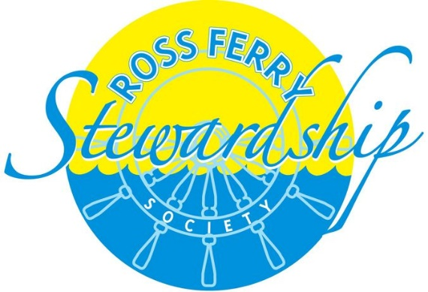
Friends of the Park*
Our Park is a designated Provincial Park which is operated independently by the Stewardship Society. Other than funding from the federal and municipal governments, primarily for a summer student, the operation and maintenance of the park is dependent on local fundraising and donations.
In 2013 we began a “Friends of the Park” campaign. A sign was erected at the park entrance to display the company name and logo of our “Friends” for that year. There are four levels of sponsorship which is reflected by the size of your advertising space. Your contribution covers one year of advertising (Sept 1 – August 31) and is tax deductible.
Levels of sponsorship are: Platinum - $2,000.00; Gold - $1,000.00; Silver - $500.00; Bronze - $250.00.
All funds raised contribute to the maintenance and improvement of our park. Our 2015 projects include installing a Green gym (donated by Victoria County) and purchasing and installing a weather-proof Community Message Board. We are also in need of a new BBQ which is an integral part of our Summer Sundays’ fundraiser.
If you have any questions or would like your contribution earmarked for a specific project please let us know. Please make your cheque payable to: The Ross Ferry Stewardship Society.
Thank you for taking the time to consider a contribution as a Friend of the Park. Your financial support is greatly appreciated and will assist in keeping a very worthwhile community project operating.
*We are currently updating the criteria for this program. For more information, please contact Terri Shobbrook, Chair @ 902.577.1129

